**Project Report: Audio Amplifier**

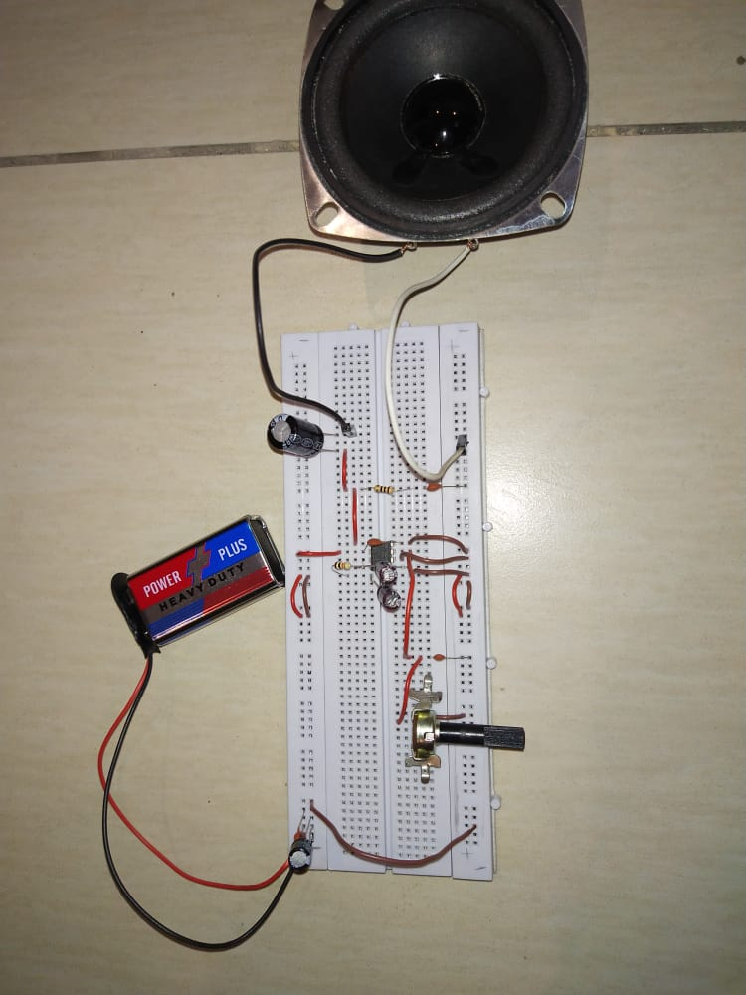

**1) Introduction**

Audio amplifiers are used for increasing the magnitude of power of a weaker audio Signal. The amplifiers used in speaker driving circuitries of televisions, mobile phones etc. come under this category.

**2) Methodology**

Firstly, LM-386 IC is put in the breadboard. For power supply battery of 9V is used. Then, 100 microfarad capacitor is put, when amplifier tries to draw more power so, to decouple it. Then 0.1 microfarad capacitor is added to little decoupling. To adjust resistance between two terminals Potentiometer is added. Then, Audio jack is used. One wire is grounded with ground layer of breadboard and other wire is goes into first pin of the potentiometer. Then, 470 picofarad capacitor is used from center pin of potentiometer and grounded using wire. Then, 10 microfarad capacitor is connected between 1st and 8th pin of LM-386 IC. Then, pin 7 which is bypass pin from which 10k resistor is connected to 10 microfarad capacitor and grounded to ground rail of breadboard. Then, 0.1 microfarad capacitor is used to connect the 4th pin and goes to grounded rail and 6th pin goes to VCC rail. Pin 2 (inverting-input) is grounded. Then inserted a wire from 470 picofarad capacitor to pin 3 (non-inverting input) of the IC. Then from pin 5 which is connected to 10ohm resistor which is connected to positive terminal of 0.1 microfarad capacitor and its negative terminal is grounded to grounded rail of breadboard. Pin 5 is also connected to positive terminal of 1000 microfarad capacitor and its negative terminal is connected to positive terminal of the speaker. The negative wire of speaker is grounded. All work is done and it is ready to use.

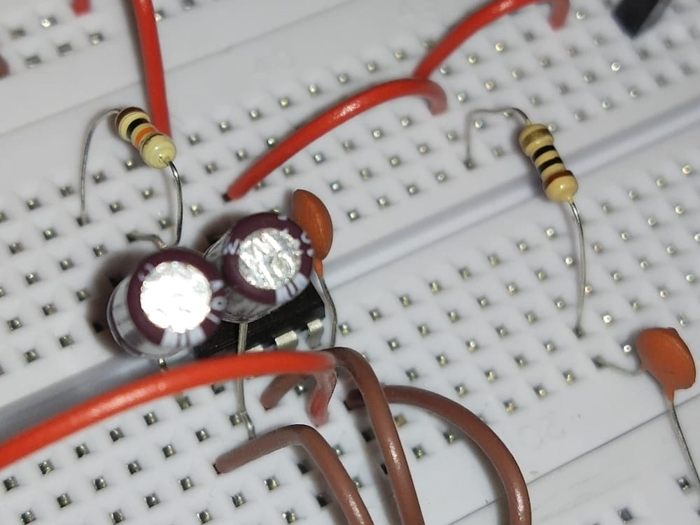

**3) Electronic components**

| S.NO | Component | Qty. |
| --- | --- | --- |
| 1. | Power supply or Battery (5V to 15V DC) | 1 |
| 2. | 100uf capacitor (used for power supply decoupling) | 1 |
| 3. | Audio jack | 1 |
| 4. | LM386 N-3 | 1 |
| 5. | 220 to 1000uf capacitor (between amp output and speaker) | 1 |
| 6. | 470pf capacitor (used to reduce RF interference) | 1 |
| 7. | 10uf capacitors (x2) (gain and bypass) | 2 |
| 8. | 0.1uf capacitors (x3) polyester tends to sound better than ceramic | 3 |
| 9. | 10 Ohm resistor | 1 |
| 10. | 10k Potentiometer | 1 |
| 11. | 8 Ohm speaker (1 watt minimum) | 1 |
| 12. | Jumper wires | 1 |
| 13. | Breadboard | 1 |

**4) Circuit diagram**

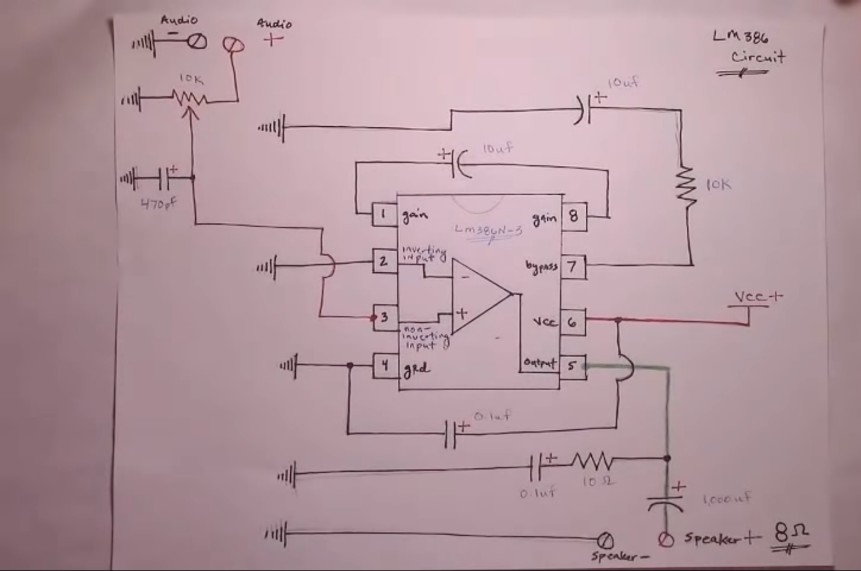

**6) Function/ working implementation of the project**

**1.** LM-386 IC

The IC consumes very less power and hence can be operated using a 9V battery easily. Power amplifier designed for use in low voltage consumer applications. The gain is set to 20 to keep external part count low, but the addition of resistor and capacitors between 1 and 8 will increase the gain to any value 20 to 200.

**2.** 100 microfarad capacitor and 0.1 microfarad capacitor

They are used to decouple the power when the amplifier tries to draw more power.

**3.** 10k Potentiometer

 A resistor with one variable end. It is a three-terminal device. 2 are fixed ends and the center one is called variable end. The terminals 1 and 2 or terminals 2 and 3 are used to obtain the variable resistance and the knob is used to vary the resistance. To adjust resistance between two terminals it is used. **3rd pin** (fixed end) is grounded to one wire of audio input, and **middle pin** is connected to 470 microfarad capacitor.

**4.** 470 microfarad capacitor

It is used for low frequency filtering and provides power supply bulk capacitance, when a lot of capacitance is needed. In this project, a 470 picofarad capacitor is used from the middle pin of the potentiometer and grounded using wire.

**5.** Audio jack:

One wire is grounded with the ground rail of the breadboard and the other wire goes to the 1st pin and 3rd pin (fixed ends) of the potentiometer.

**6.** 10k resistor and 10 microfarad capacitor

**Pin 7** which is a bypass **pin** from which a 10k resistor is connected to a 10 microfarad capacitor and grounded to the ground rail of the breadboard.

**7.** Bypass pin: 7 and 10 microfarad capacitor

From pin 7, a 10k resistor is connected to the positive rail of the 10 microfarad capacitor and its negative rail is grounded to the ground layer of the breadboard using wires. This is done because any noise coming on the audio signal helps to reduce that noise.

**8.** Pin 4th, 6th and 0.1 microfarad capacitor:

To help reduce the noise and power supply, 0.1 microfarad capacitor is used. It connects the 4th and 6th pins of the IC. 4th pin goes to ground rail and 6th pin goes to VCC rail.

**9**. 1000 microfarad capacitor

Pin 5 is also connected to the positive terminal of a 1000 microfarad capacitor and its negative terminal is connected to the negative terminal of the speaker.

**10**. Breadboard and 8Ohm Speaker

 The board into which circuit components IC, resistors, and capacitors are inserted. Pin 5 is also connected to the positive terminal of the 1000 microfarad capacitor and its negative terminal is connected to the positive terminal of the 8 ohm speaker. The negative wire of the speaker is grounded.

**7) Applications**

Audio amplifiers are used in:

1. AM and FM Radio amplifiers
2. Portable music players
3. TV sound system
4. Line drivers
5. Low Power Audio amplifiers

**8) Motivation**

The purpose of this experiment is to introduce the audio amplifiers using the audio amplifier integrated circuit (IC) **LM386** and then measuring the amplifier performance. One can control the gain and remove the noises by using LM386 (IC).

**10) Conclusion**

The goal of **audio amplifier** is to reproduce input audio signals at sound-producing output elements, with desired volume and power levels efficiently, and at low distortion. LM-386 IC is selected. For power supply battery of 9 volt is used. 100 microfarad capacitor and 0.1 microfarad capacitor are used to decouple the power. To adjust resistance a 10k potentiometer is used. From pin 7, 10k resistor is connected to the positive rail of the 10 microfarad capacitor and its negative rail to the ground rail of the breadboard. Pin 5 is connected to the positive terminal of a 1000 microfarad capacitor and its negative terminal is connected to the negative one of the speaker. The negative wire of the speaker is grounded. The wire of AUDIO JACK is grounded and goes to the 1st pin and 3rd pin (fixed ends) of the potentiometer. It is used in music players, drivers and audio boosters etc.

**11) Reference**

Information of Audio Amplifier taken from: - [**https://youtu.be/XHkKIEAo1vc**](https://youtu.be/XHkKIEAo1vc)

Information of the LM386 IC taken from: -

[**https://components101.com/ics/lm386-audio-amplifier-ic-pinout-circuit-datasheet**](https://components101.com/ics/lm386-audio-amplifier-ic-pinout-circuit-datasheet)